**Disciplined Entrepreneurship Workbook**

# Step 7: High-Level Product Specification

## Worksheets

### Visual Representation of Product

In the space below (and use more sheets if need be, but keep it to less than three sheets) build a visual representation of your product and how it works. Annotate your drawings, but do not burden them with too much detail.

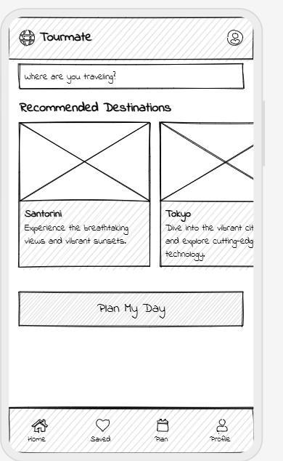

Home screen

Recommendations and day plan screen

Premium guide screen

### Product Alignment with Persona

|  |  |  |  |  |
| --- | --- | --- | --- | --- |
|  | **How will you deliver a new level of value with respect to this priority?** | **What features address this priority?** | **What functions address this priority?** | **What benefits address this priority?** |
| **Persona’s #1 Priority:**  **___________________ Instant , Reliable travel recomendations__** | **By providing real-time, localized travel insights powered by an ai chatbot and data harvesting** | **A dynamic search bar with live suggestions and personalized itinerary cards** | **Location tracking, real time updates and an AI recommendations engine** | **Faster decision making enhanced travel planning and increased travel confidence** |
| **Persona’s #2 Priority:Seamless integration and personalization**  **_____________________** | **Through a fully integrated app that syncs with social media and other travel tools offering customizable travel itineraries** | **A customizable plan builder, social media sharing options and seamless integration with calendars** | **Data synchronization adaptive itinerary planning and personalized notifications** | **A tailored travel experience that adapts to the users preferences and lifestyle offering convenience and personalization** |
| **Persona’s #3 Priority: Premium Travel Experience with exclusive Benefits**  **_____________________** | **By offering premium services like access to professional local guides, offline maps and exclusive partner deals** | **The premium upgrade screen featuring a direct chat with local experts offline functionality and exclusive offers** | **24/7 professional guidance chat, offline content access and curated premium content** | **An elevated travel experience with added value, improved convenience and access to high quality exclusive travel information** |

### Ready for Action?

* 1. Is the high-level product specification ready to review with your Persona? (circle one) Yes No

Yes

* 1. Have you done so? What feedback did the Persona provide?

Preliminary reviews indicated that clear separation between free and premium features is appreciated and users suggested a more prominent display of premium benefits along with a simplified subscription process

_____________________________________________________________________________________

_____________________________________________________________________________________

* 1. Have you iterated based on the Persona’s feedback at least once? What changes did you make as a response to the Persona’s feedback? (Hopefully you will iterate with the Persona more than once.)

Yes, we refined the UI to make the premium upgrade button more visible and streamlined the plan generation process to make navigation more intuitive

_____________________________________________________________________________________

_____________________________________________________________________________________

* 1. Has the Persona concluded that the high-level product specification is interesting and satisfies the Persona’s priorities?  
     (circle one) Yes No

YES

## ADVANCED TOPICS: HIGH LEVEL PRODUCT BROCHURE

Once you have iterated on your high-level product specification, you may want to build a trifold brochure that more clearly outlines the benefits your product provides. Some people will wait to make a brochure until they have iterated the specification with other customers in Step 9, Identify Your Next 10 Customers, but others find a brochure useful at this stage.

A good brochure should have the following items:

* First draft of company name and tag line
* Name of product and tag line
* Picture of product so it is clear what it is
* Clearly identified benefits aligned with the Persona’s #1 priority (don’t be subtle – it should come out in the tag lines and even names of your product)
* Two additional benefits (if appropriate) that don’t dilute the impact of the first benefit
* Provide a sense of the magnitude of the benefit to be expected by the end user
* Provide a sense of the value the customer will gain from your product – use your work from the Step 6 Full Life Cycle Use Case
* Some other information might be relevant, but always be diligent about not diluting your main message – if you say too much, you say nothing in particular
* Have a clear call to action
* Everything should be fully aligned with the customer’s priorities and will resonate with them in all elements (e.g. names, taglines, pictures, benefits emphasized, fonts, colors, word choice, language, references, call to action, etc.)

There are great individuals and agencies you can hire to design brochures, and you’re not expected to become an expert in design. But you want to think through the content and make sure it is compelling and addresses the Persona’s priorities. That way, if you choose to delegate or outsource the design, you can give them good direction and not settle for an inferior brochure.

Ultimately, the brochure is the most commonly and widely given elevator pitch about your product because it can be done when you are not in the room and even when you are sleeping. It make consistent messaging possible and scalable, so don’t just down play it as “marketing hype.” It really matters.

You also have to back it up with a great product, but that is coming. First, you have to make sure you are building the right product for your customer, and this process really helps to communicate that to all sides.